**Zebo Xiong – A04907051 (HW3)**

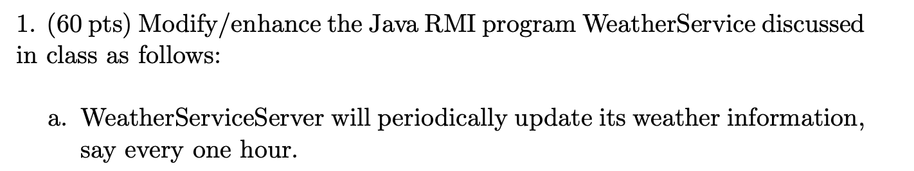

1. Run server:

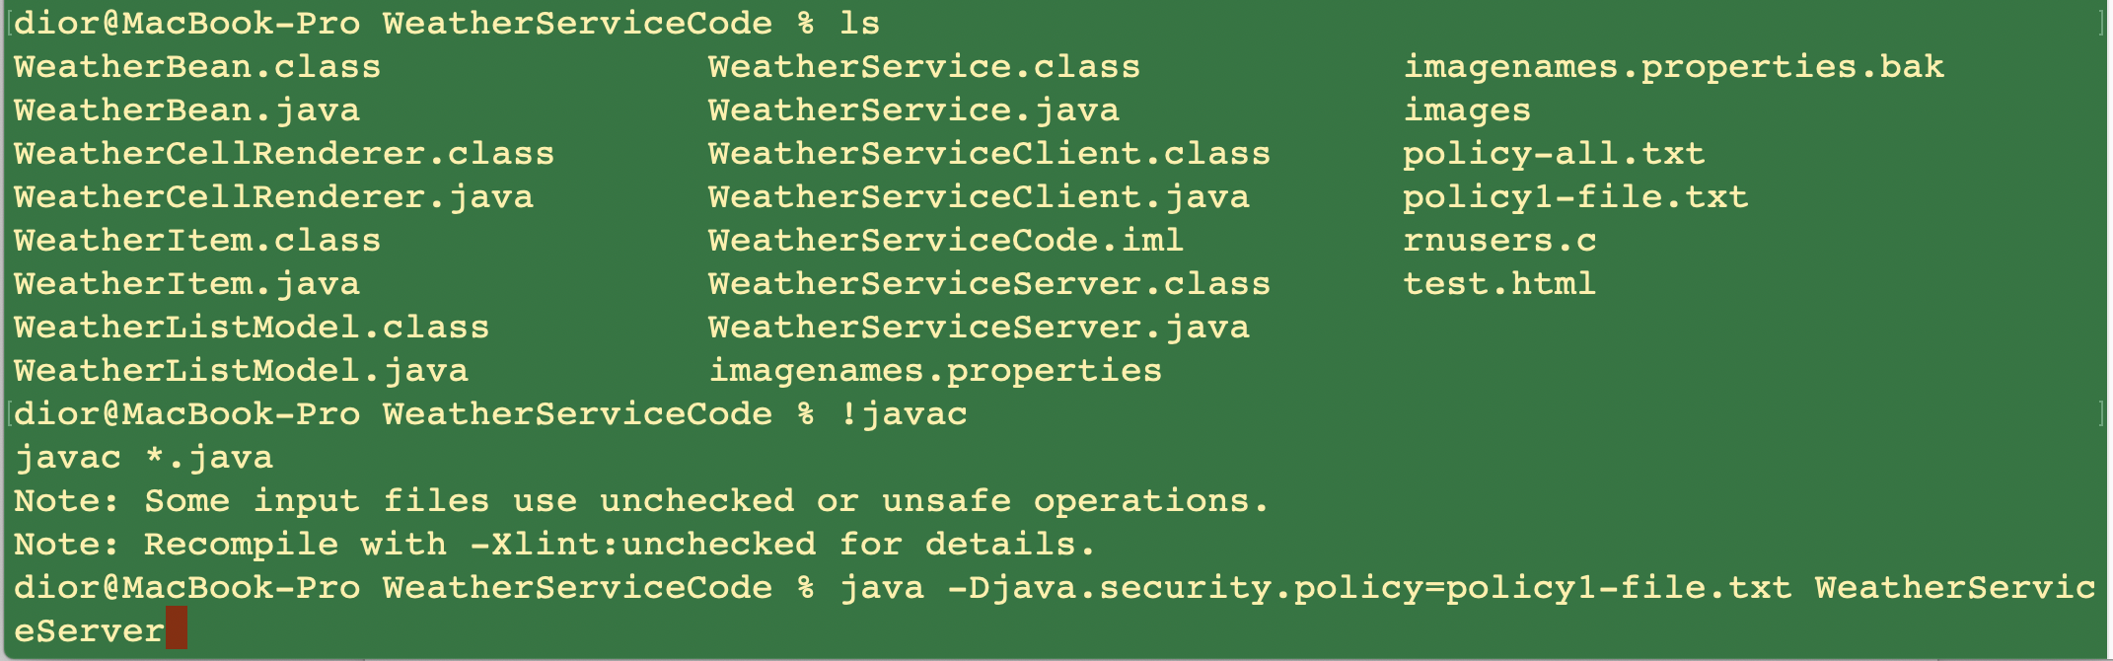

1. The server will update weather information every one hour

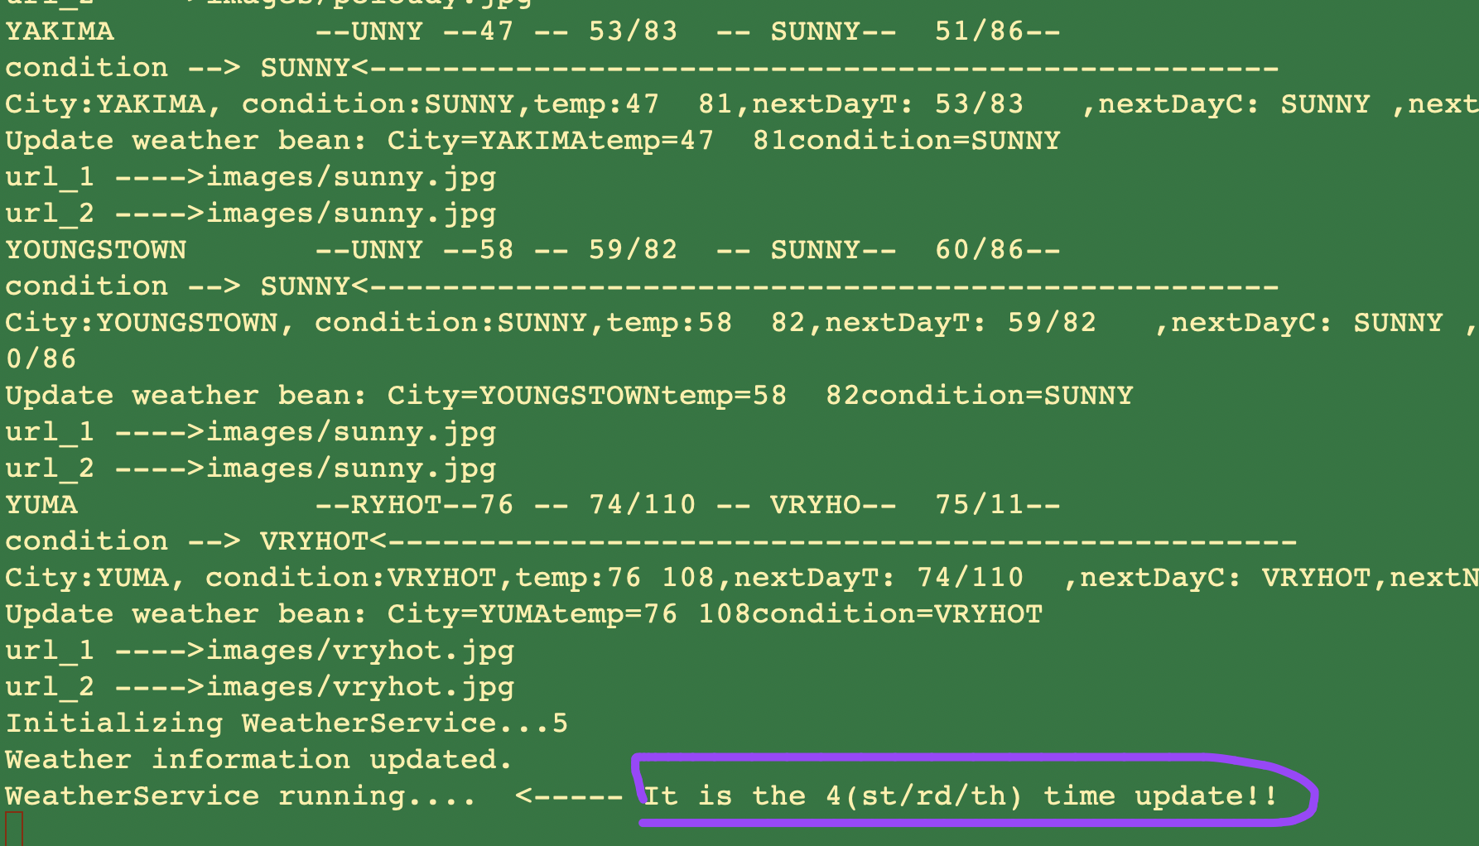

1. The code in server side:

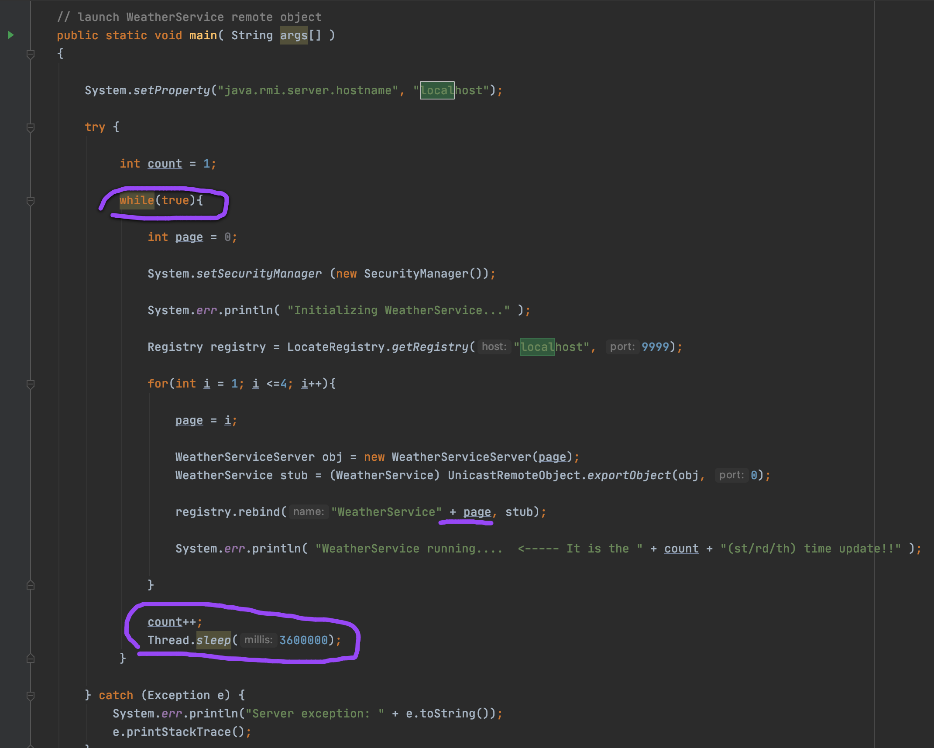

The while loop was used and it will pull the data from HTTP server every 3600 seconds.

1. Also, in the client side,

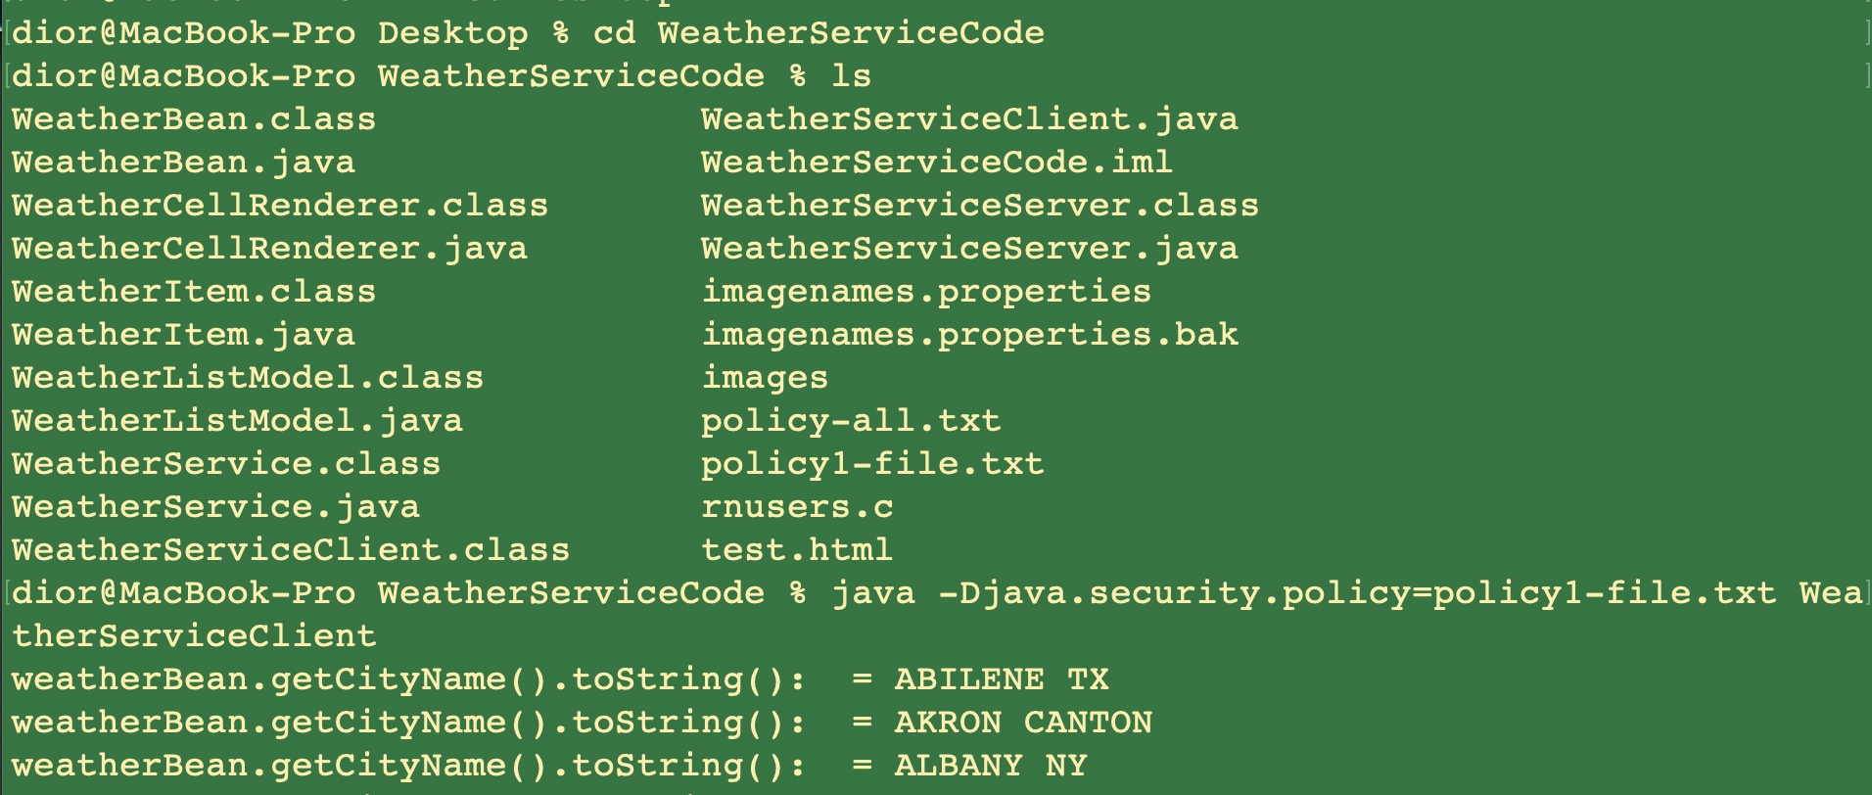

1. This is the code from client: (call data from server every one hour)

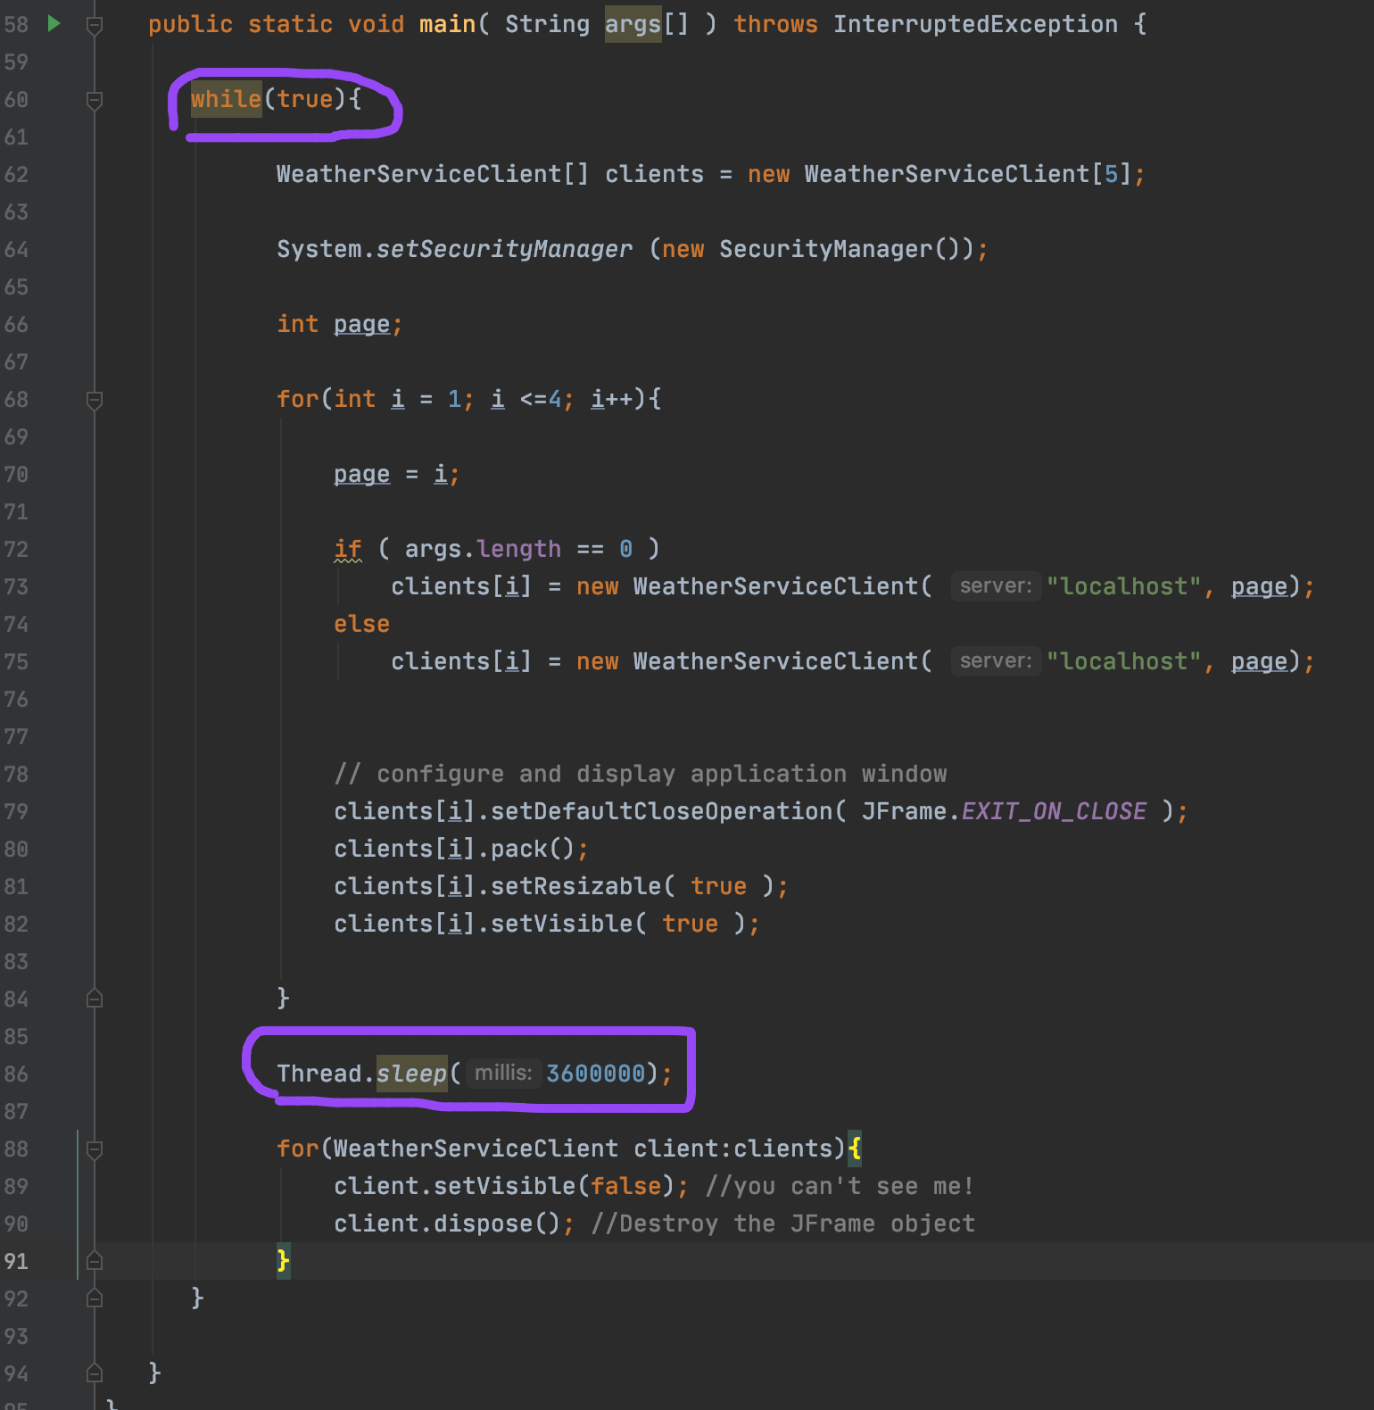

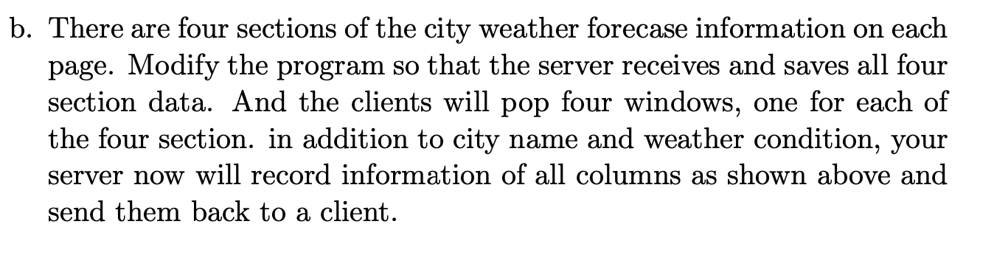

1. I pull the data from four different sections:

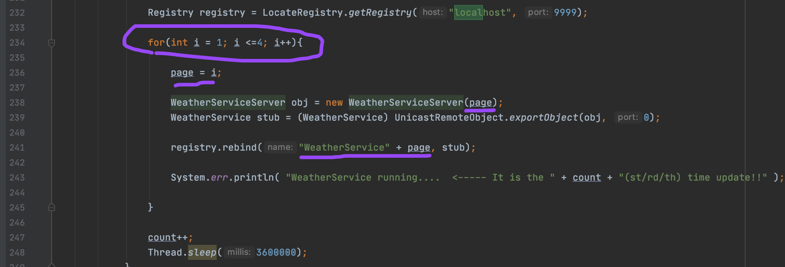

1. I used variable page to indicate the different sections

1. Also in client side, I will display the four sections in different windows:

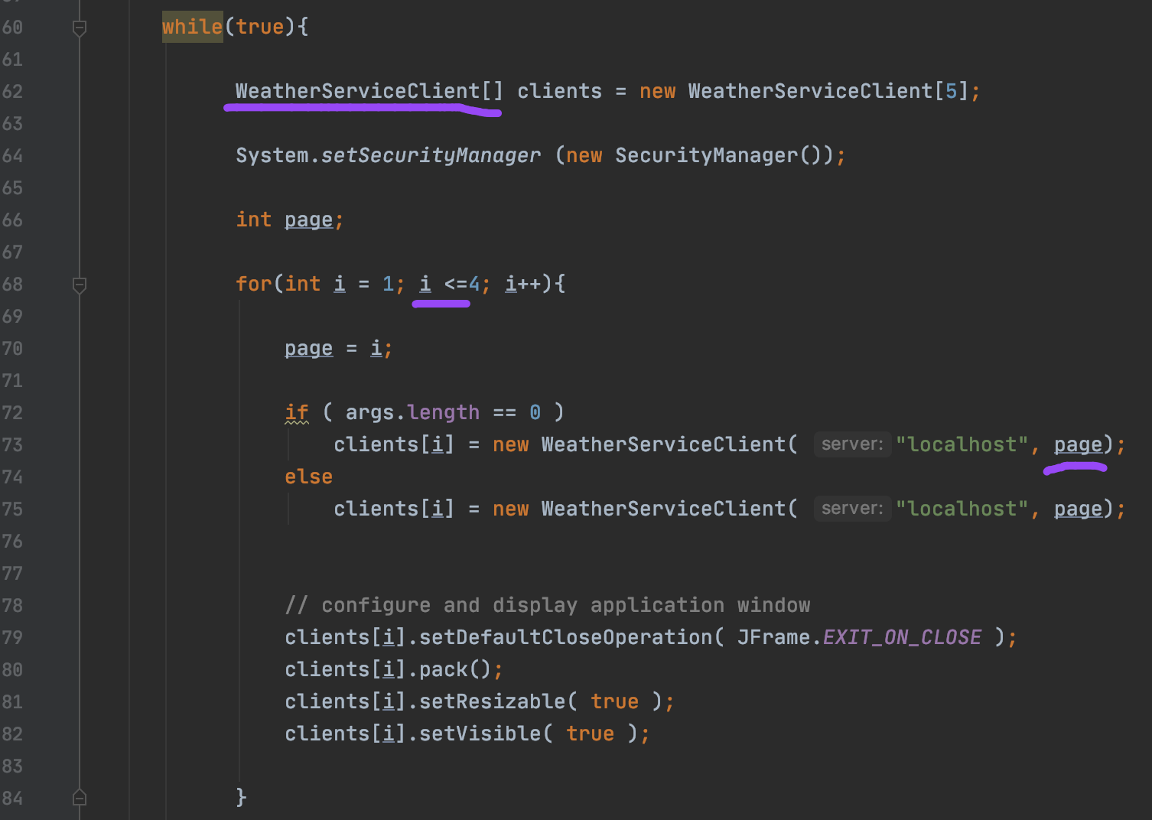

1. Four windows has shown:

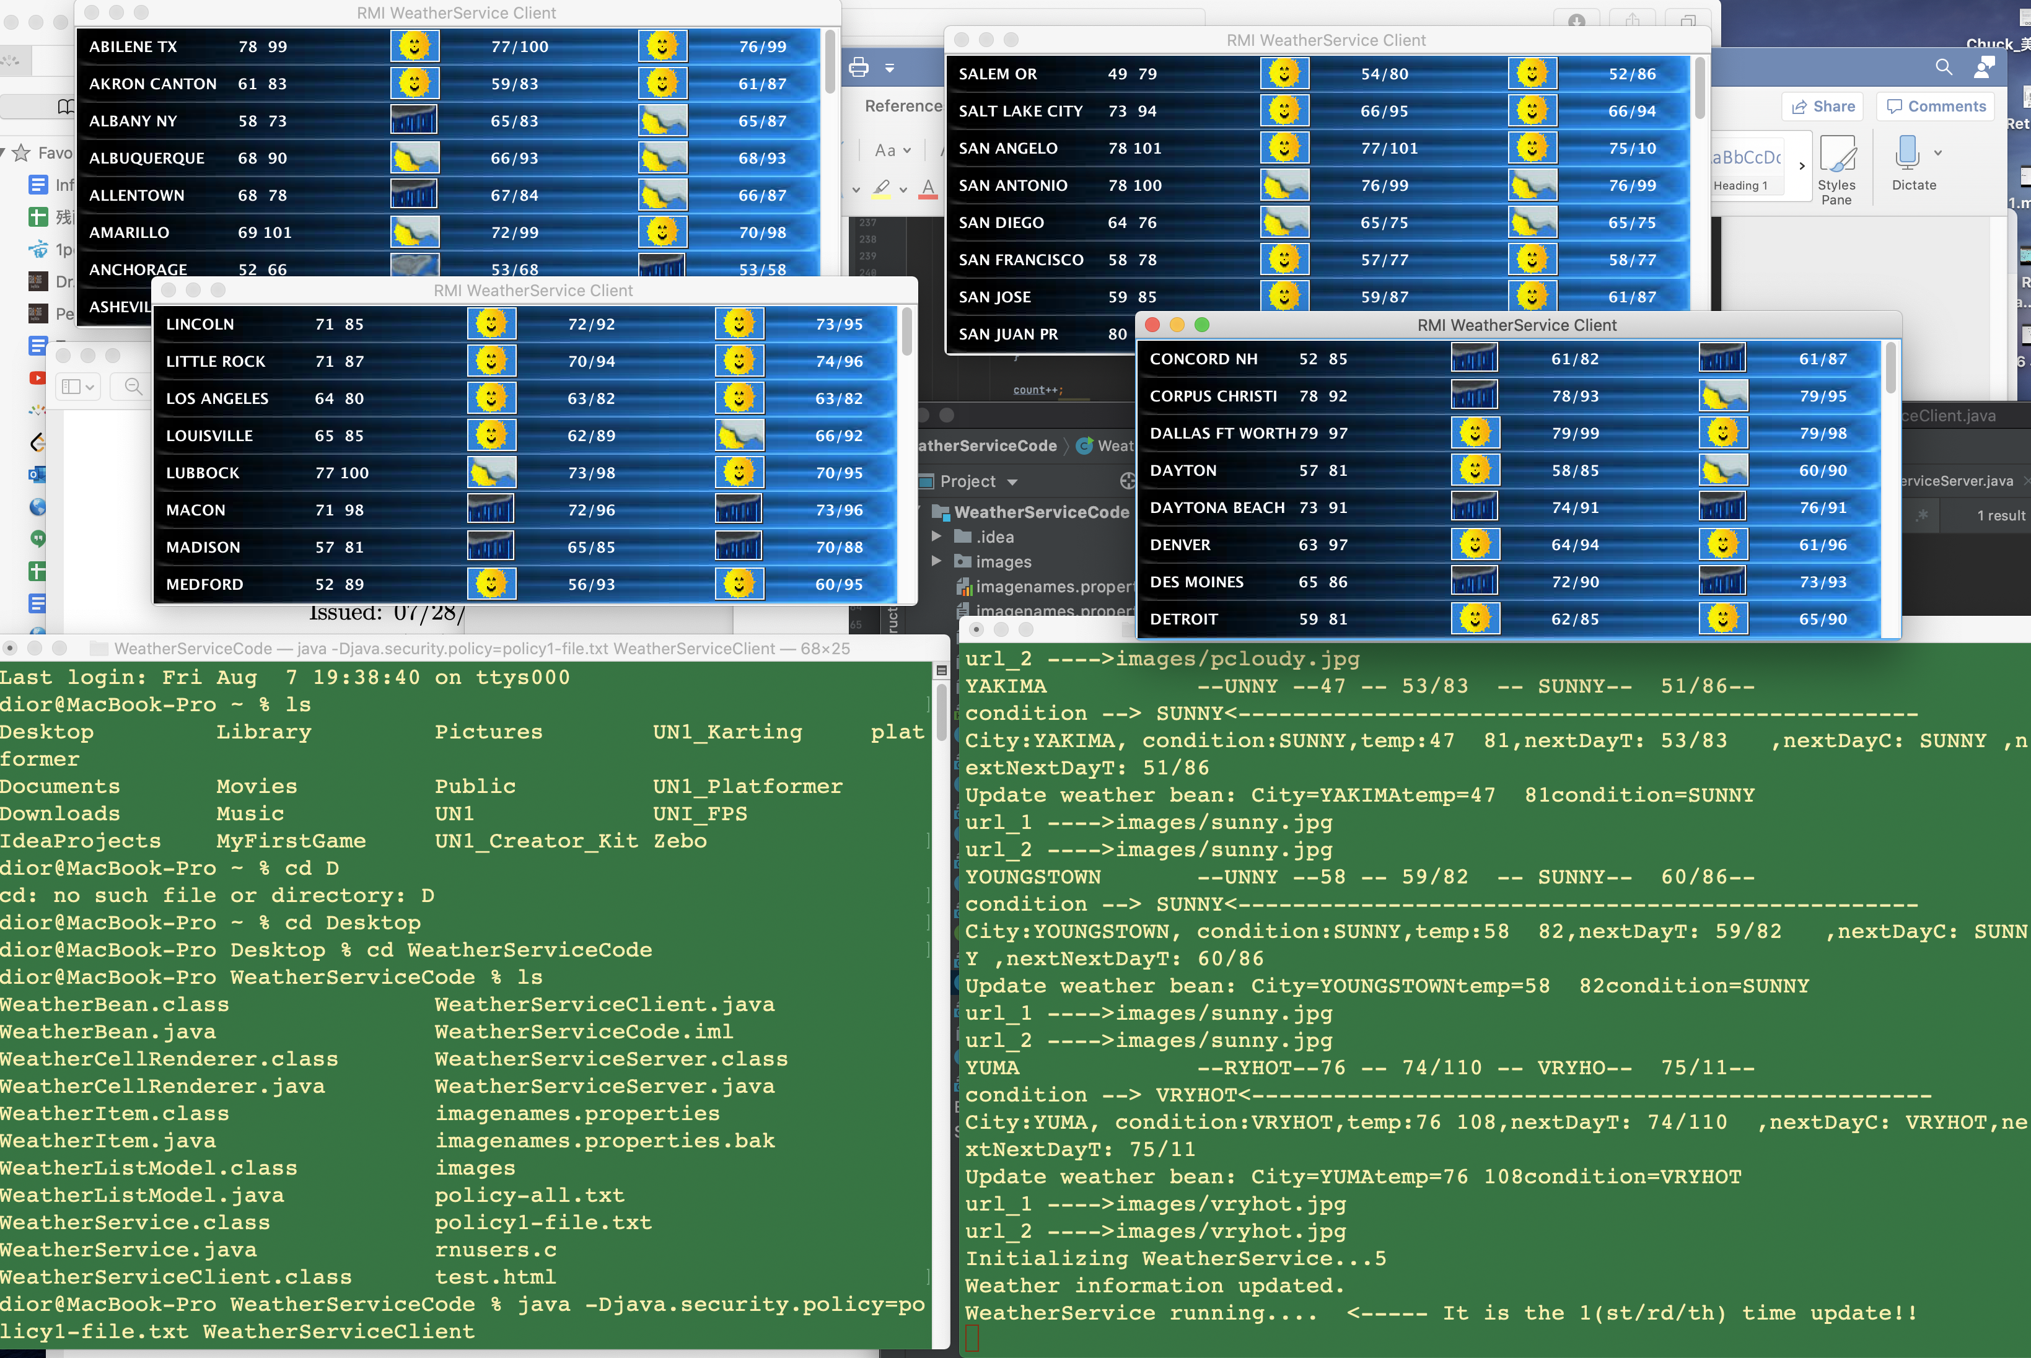

1. Besides, I mapped “Mostly Cloudy” icon:

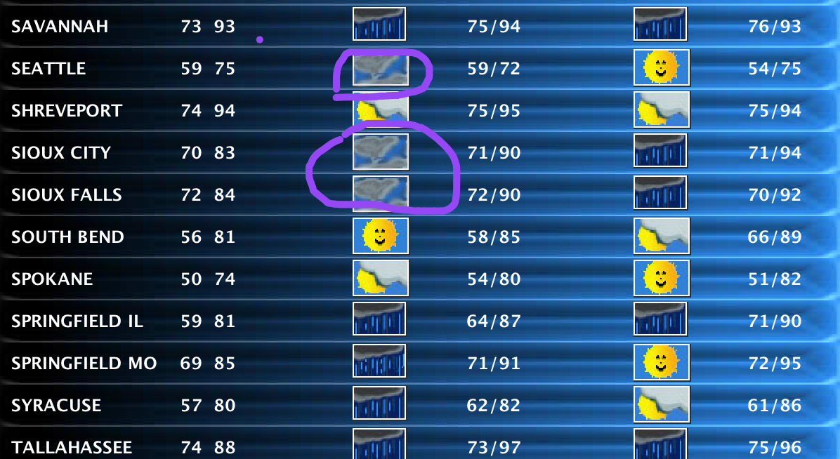

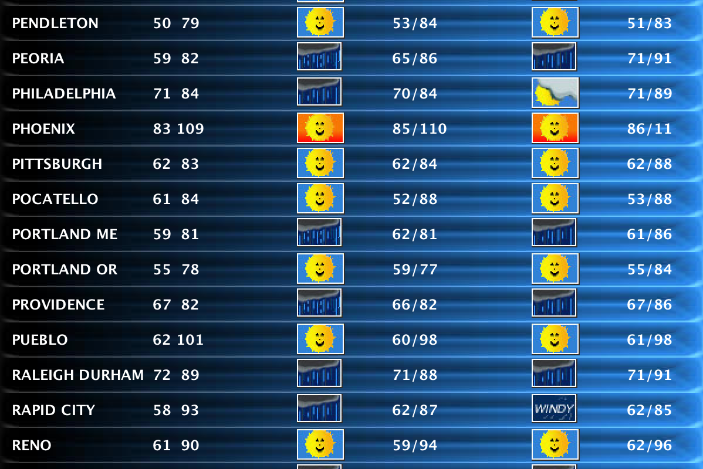

1. The code to add extra column in WeatherServiceServer:

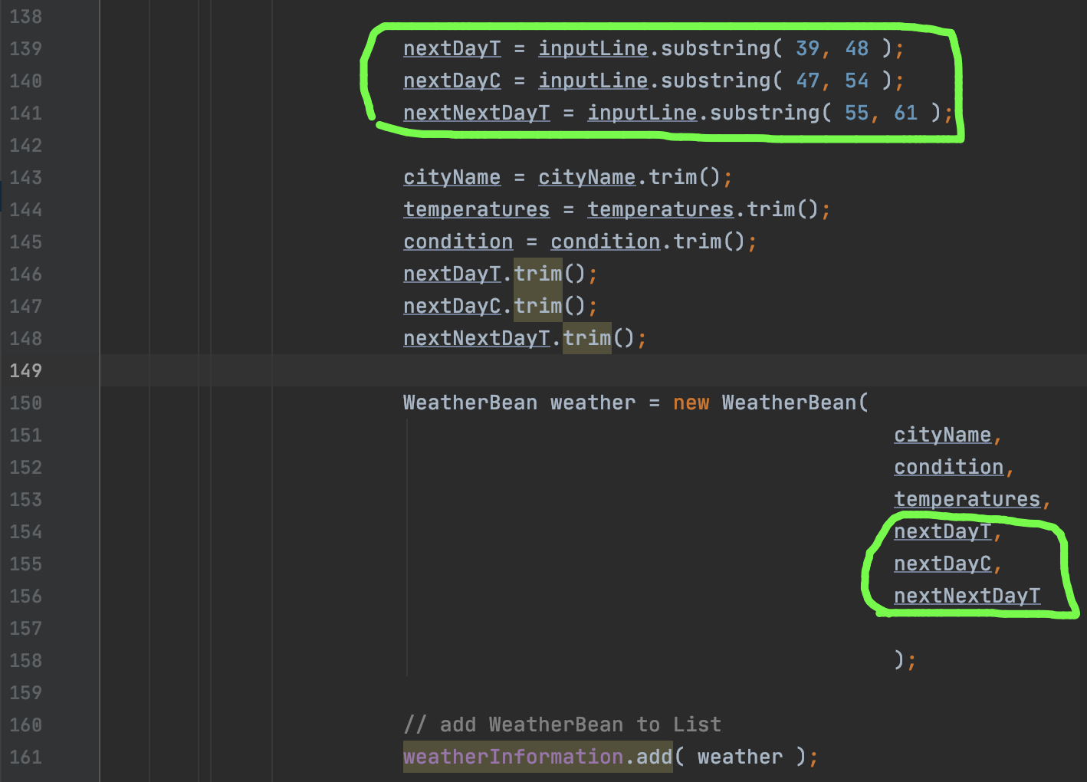

1. The code to be added in WeatherBean:

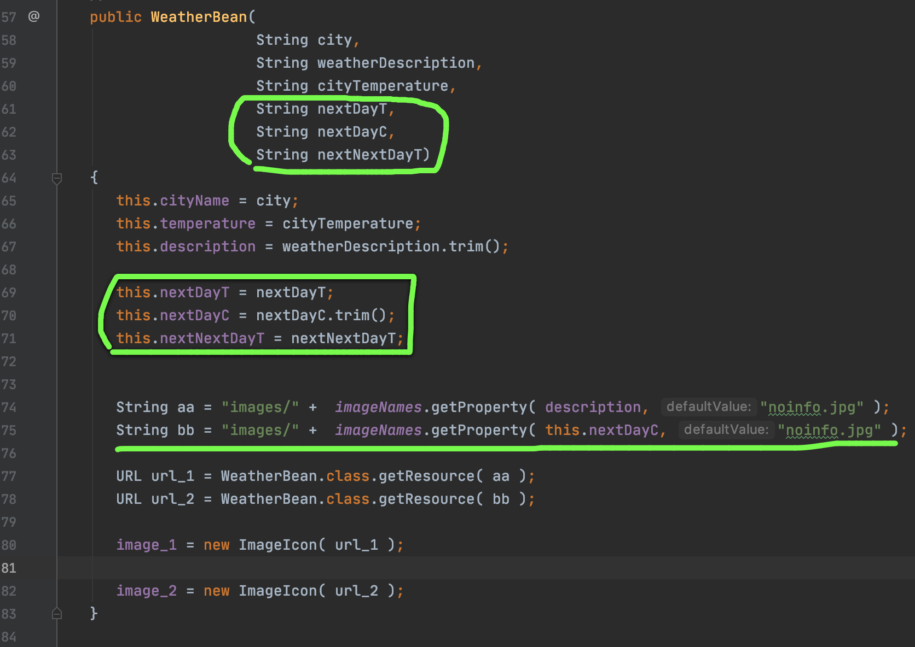

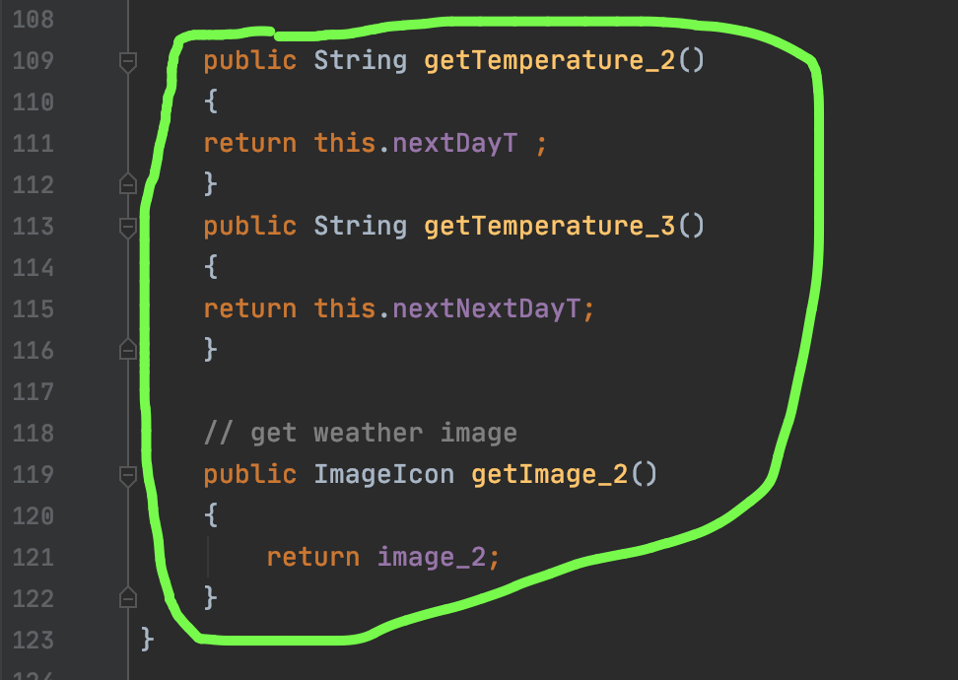

1. The code added to WeatherItem:

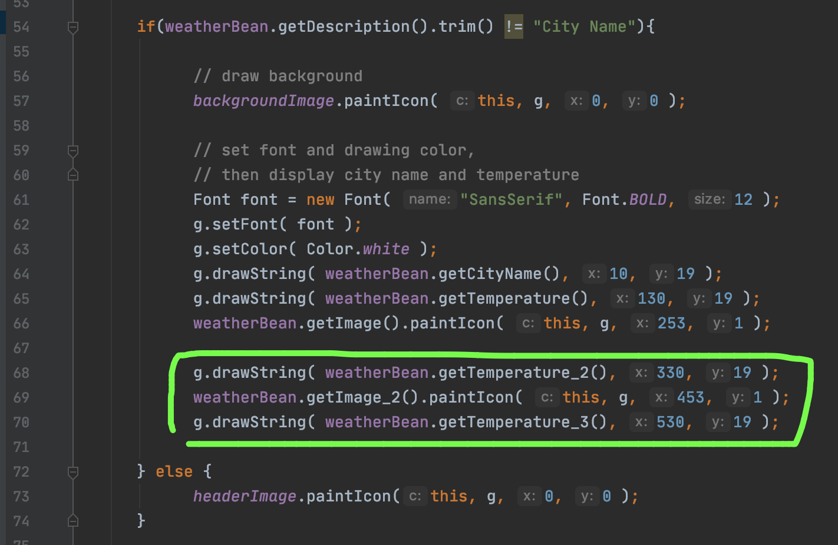

Also, I tried to compile on server zeus, but not successful. I login server and copied code to zeus:

1. ssh z_x3@zeus.cs.txstate.edu
2. scp WeatherServiceCode.zip z_x3@zeus.cs.txstate.edu:/home/Students/z_x3/5352_summer

­­­­­­

1. unzip WeatherServiceCode.zip

1. I updated the policy file and even test with absolute path. However, “WeatherBean.class.getResource()” keep return null. It seems that it could not find the correct image path.

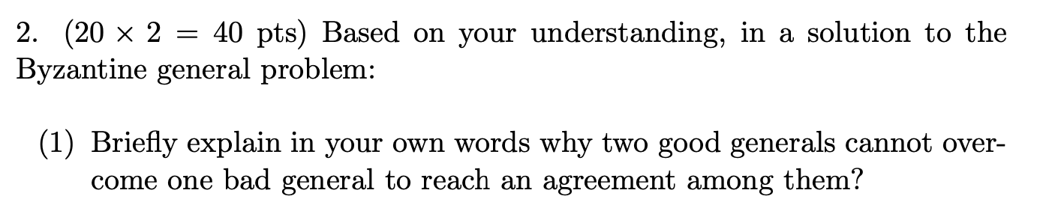

As we discussed in class, if there are three generals, and one of them is bad, it is no way to align the action. Let us say they are general A, B, C.

Case one: General A is bad. He give true message to B, and false message to C. Even though B and C exchange their received message from A, both B and C have 50% true message and 50% false message. B and C cannot tell which one is correct

Case two: General A is good. He will both true message to B and C. However, B is bad. B exchange a bad message to C, and then C have 50% true message (from A) and 50% false message (from B). C cannot make decision.

Case three: same as case two if A is good while C is bad. (A will still give true message to both B and C)

They cannot reach an agreement – the “majority” function is not working in this 50% true 50% false situation.

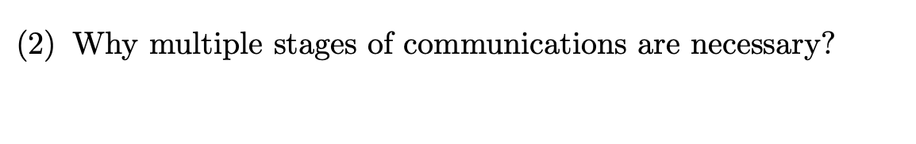

1. There exists bad general (faulty process) who may modify the contents of an incoming message, and forward wrong message deliberately. It can be accident or being hacked.
2. The name (id) of the message of a message is unknown to the receiver;
3. The bad general may choose not to forward any message after receiving;
4. It means any messenger can be attacked or lost or stopped during the communication.
5. In this case, we need multiple stage of communication to overcome the faulty processes (bad general). By multiple stage of communication, the good general can finally pass the correct message to the receiver.
6. After multiple stages, all the good general (except the traitor) can use “majority rule” to make the decision.
7. If the maximum number of faulty processes is T at beginning, then any solution to the problem will need at least T + 1 stages of message exchanges to arrive at a consensus.
8. To sum up, we need the multiple stage to overcome the inconsistent information and failure situation, and finally reach a correct decision with all generals. (The so-called “Practical Byzantine Fault Tolerance” derives from this)